EENG 284 – Digital Design

Lab 10 – Stop Watch Control Unit

# Objective

The objective of this lab is to design a control unit to control the datapath created in the previous lab so that, together, they can run the stopwatch.

**1 Discussion**

From the previous lab, you should be familiar with the operation of our stopwatch. Briefly, our stopwatch allows a user to measure elapsed time and lap times of a competitive events. Our stopwatch measures time in increments of a tenth of a second, unit second and tens of seconds. Control input comes from 2 buttons called S1 and S2 according to the incomplete finite state machine shown in Figure 1.

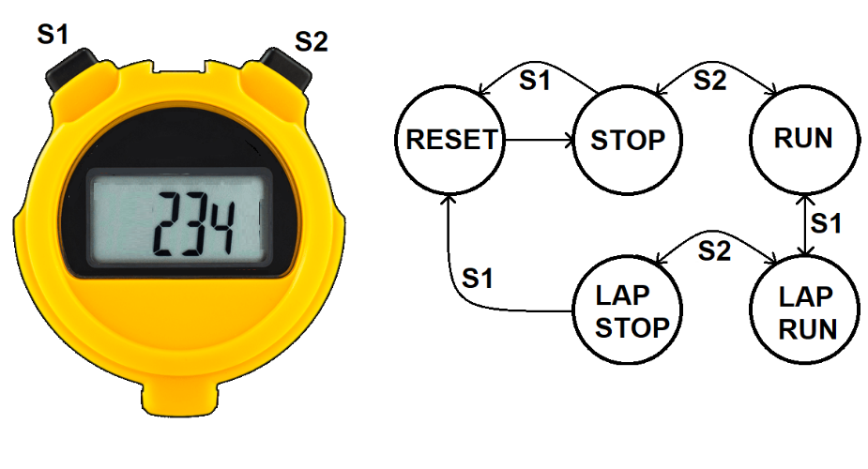

Figure 1: A digital stopwatch gets its input from 2 buttons and displays its output on a 7-segment display. The behavior of the stopwatch can be described by this finite state machine (FSM).

There are two reasons that the FSM shown in in Figure 1 is incomplete, it does not reflect the logic level of the buttons on the C5G board nor does it account for the time the user holds the S1 and S2 buttons down.

Figure 2 shows the schematic of the buttons (key1 …key4) on the C5G development board that you will use to control the operation of the stopwatch; the S1 and S2 buttons in Figure 1. The buttons shown in the schematic are in their nominal position – not being pressed by a user. You should note that the contacts of each button (open circles) are disconnected. This leaves the right side of the button connected to VCC through a resistor as well as the Altera FPGA. This resistor is called a pull-up resistor, and as its name implies, pulls the voltage on the right side of the push button up to VCC – logic 1. When a button is pressed, the contacts are connected and the right side of the push button is connected directly to ground, forcing the voltage on the respective FPGA pin to logic 0.

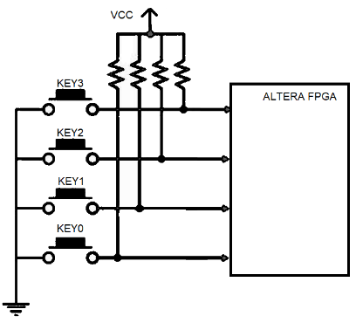

Figure 2: C5G buttons used to operate the stopwatch.

To summarize the operation of the buttons shown in Figure 2. When a user presses a button, the value on the respective FPGA pin is logic 0. When a button is not pressed, the logic level of the corresponding FPGA pin is logic 1.

You will explore the reason that effect of the user holding down a button in the next section which introduces you to the finite state machine that governs the behavior of your stopwatch.

**2 Control unit architecture**

The control unit for the stopwatch is shown in Figure 3.

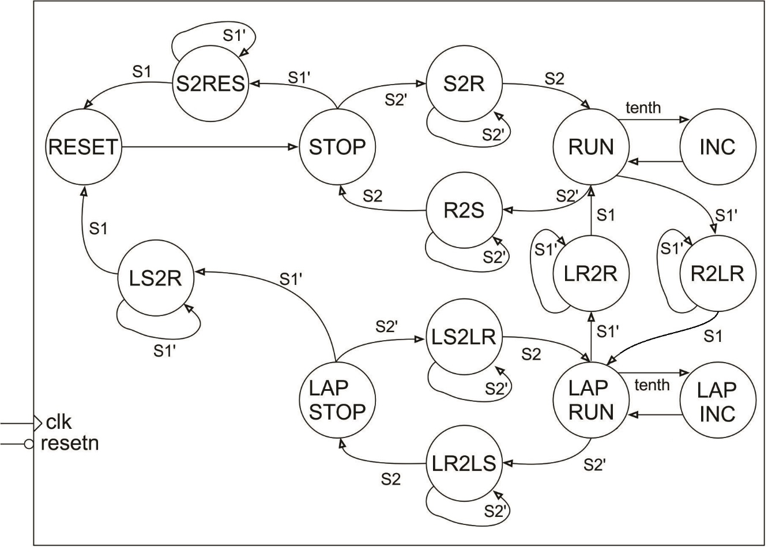

Figure 3: The control unit for the stopwatch needs to account for the time the user holds the button down.

The arcs between states are labeled with a Boolean condition, which when true, causes the FSM to make that transition. So for example, if the FSM is in the RUN state and the S2 button is pressed (buttons output 0 when pressed hence the arc labeled S2’), the FSM will transition to the R2S state (and stay there as long as the button is held down). When a number “2” appears in the middle of a state name, the number denotes the word “to” which is intended to mean moving from one state to another. The abbreviated names of the source/destination states are written on left/right side of the number “2” respectively. So for example, the state R2S stands for Run to Stop.

These intermediate states are needed because the action of a user pressing a button takes a long time from the perspective of the 50MHz clock on the C5G. For example, consider the incorrectly designed FSM shown in Figure 4. The intention of this design is to have the FSM transition from the STOP state to the RUN state when the user pressed the button S2 (remember that when S2 is pressed it outputs a logic 0, hence the arc labeled S2’). What actually happens is that the FSM rapidly toggles between the STOP and RUN states at 50MHz while the S2 button is held down. When the user releases the S2 button there is a 50/50 chance that the FSM will end-up in the STOP or RUN state.

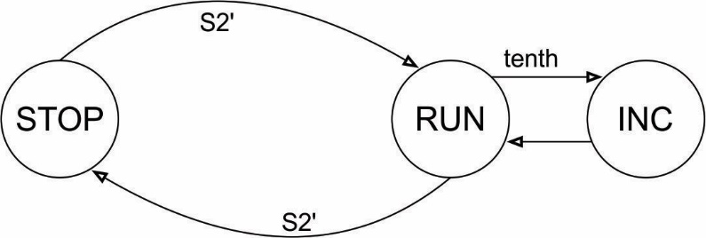

Figure 4: An improperly constructed FSM for the stopwatch.

Before you dive into writing the Verilog code for the control unit, you need to complete Table 1, the control word value for each state. You have already completed some of these control words in the previous lab. Most of the new states are the states with “2” in them. We will call these “transitional states” because they move the control unit between stopwatch modes. When writing the control words in Table 1 you must follow the following 2 rules.

1. Assign the cw[5] bit for transitional states the same value as the cw[5] value for the source state. So for example in the R2LR state, set cw[5] to 0 because the cw[5] value in the source state, RUN, is 0.
2. Only have the timer counter counting up while the control unit is in the RUN or LAPRUN states. We don’t want the timer counting up in intermediate states because these states do not have an “INC” associated with them, and as a consequence, the tenth pulse from the timer counter would most likely be missed.

Table 1: Control word table for the stopwatch finite state machine shown in Figure 3.

|  |  |  |  |  |  |
| --- | --- | --- | --- | --- | --- |
|  | cw[5]  2x1 mux | cw[4]  lap register | cw[3]  mod 10 reset | cw[2]  mod10 count | cw[1:0]  timer counter |
|  | 0 = mod10 | 1 = load | 1 = reset | 1 = count up | 11 = load |
|  | 1 = register | 0 = hold | 0 = hold | 0 = hold | 10 = count up |
|  |  |  |  |  | 01 = not used |
|  |  |  |  |  | 00 = hold |
| RESET |  |  |  | 0 |  |
| STOP |  |  |  |  |  |
| S2RES |  |  |  |  |  |
| S2R |  |  |  |  |  |
| RUN | 0 |  |  |  |  |
| R2LR | 0 |  |  |  |  |
| R2S |  |  |  |  |  |
| INC |  |  |  |  |  |
| LAPRUN |  |  |  |  | 10 |
| LR2R |  |  |  |  |  |
| LR2LS |  |  |  |  |  |
| LAPINC |  |  |  |  |  |
| LAPSTOP |  |  | 0 |  |  |
| LS2R |  |  |  |  |  |
| LS2LR |  |  |  |  |  |

After you complete the control word table, you are ready to write the Verilog for the control unit. This file will have the following main sections.

* Port description – This has been provided to you.
* Control word values – This is a set of localparam statements, one for each state. You will define the control word output for each state. This will include all the control words that you derived in the previous lab, plus some new control words for the intermediate states. For example, the following is the control word for the STOP state.

localparam STOP_CW = 6'b000000;

* State codes – Each state needs to be assigned a unique binary value. It does not matter what code you assign which state. These codes are mostly invisible. That said, you will want them handy when performing the simulation so that you know which state the control unit is in. For example, the following is the state code that I used for the STOP state. Note, your codes can be different.

STOP_STATE = 4'b0010,

* Reset logic – this has been provided to you.
* Output logic – This is an always/case statement that has one case for each state and simple associated the control word output with the appropriate control word for the state that the FSM is currently in. For example, the following is the case statement that I used to associate the STOP state control word with the STOP state code.

STOP_STATE: cw = STOP_CW;

* Next state logic – This is an always/case statement that has one case for each state. It embodies the logic in Figure 3 using if/then statements. Let’s redraw Figure 3 by focusing on the states connected to the STOP state by transition arcs in Figure 5.

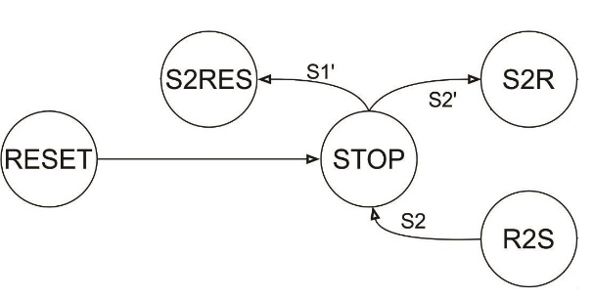

Figure 5: All the states and with a transition arc connected to the STOP state.

The next state logic for the STOP state embodies the 2 transition arcs leaving the STOP state in Figure 5. If the FSM is in the STOP state and the S1 input equals 1 then the FSM should go to the S2RES state. This logic and the transition to the state S2R is provided in the following code snippet. You must specify every possible next state, even when the next state does not change. Thus, I prefer to use a case statement and leave the default case to be when the next state is equal to the current state.

STOP_STATE:

begin

case({S2,S1})

2'b10: nextstate = S2RES_STATE;

2'b01: nextstate = S2R_STATE;

default: nextstate = STOP_STATE;

endcase

end

When writing code for the control unit, I want you to:

* Use the controlUnit.v file provided in the Canvas folder as the starting point.
* Provide meaningful names to the wires in the module.
* Properly tab-indent your code. You can use View -> Show White Space
  + Single level for wire declarations
  + Single level for component instantiations
  + Two levels for case statement
  + Three levels for case values

Compile the Verilog code for the control unit, look for and remove the errors. When the control unit compiles cleanly, it’s time to simulate to check that it behaves correctly.

**3 Control simulation**

Before you download your completed control unit to the C5G boards, you are going to perform an extensive simulation to uncover as many bugs as possible. Trust me, errors are much, much easier to find in a simulation. The goal of this simulation is to cover every transition arc in Figure 3 so that you can be sure your code is working correct.

The timing diagrams shown in Figure 6 through Figure 9 show the tenths, S1 and S2 signals as they are manipulated by the testbench. These signals will affect the state of the control unit according to Figure 3. Your task is to use these signals to determine what the state the control unit is in.

The goal of the testbench was to cover every transition arc in Figure 3. This goal was not achieved; one transition arc was not taken in the testbench, which one was it?

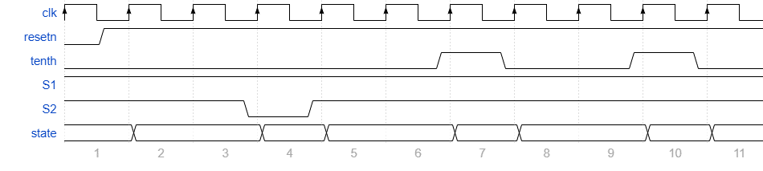

Figure 6: Timing diagram for the testbench simulation for the first 11 clock cycles.

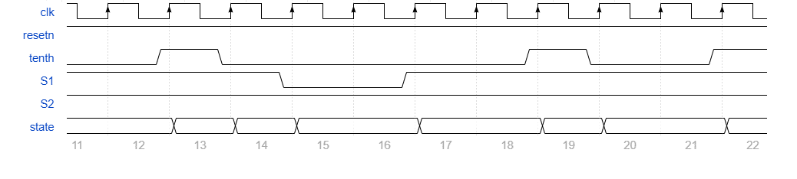

Figure 7: Timing diagram for the testbench for the second set of 11 clock cycles.

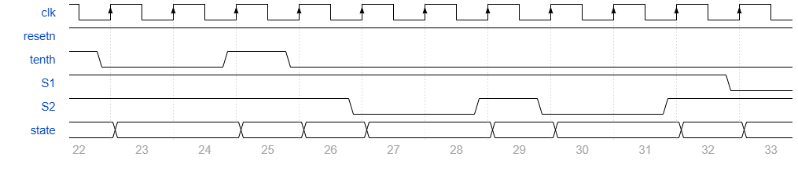

Figure 8: Timing diagram for the testbench for the third set of 11 clock cycles.

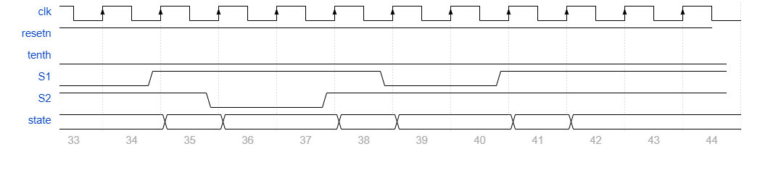

Figure 9: Timing diagram for the testbench for the fourth and final set of 11 clock cycles.

Now that you have an understanding of what the testbench should do, it’s time to run the simulation. Complete the provided do file to simplify testing your control unit. Your timing diagram should have the following waveforms.

* + clk default green trace
  + resetn default green trace
  + cw hex yellow trace
  + tenth default orange trace
  + S2 default orange trace
  + S1 default orange trace
  + state special red stop/stop2reset/reset/stop2run

yellow run/inc/run2lapRun/run2stop

orange lapRun/lapInc/lapRun2run/lapRun2lapStop

green lapStop/lapStop2run/lapStop2LapRun

When editing the do file for this lab, note the following.

* Correct the waveform names as needed. This might happen if you name a signal differently than I did.
* Create alias’ for each state code. When you coded the control unit by assigning an arbitrary 4-bit value to each state. In Listing 1 you will associate each of these 4-bit values to a string and a color. The string should correspond to the name of the state and the color to something identifiable when the simulation is running. For example, you may remember that I assigned STOP_STATE = 4'b0010. This corresponds to the line “4'b0010 "STOP" -color red,” in Listing 1

radix define States {

…

4'b0010 "STOP" -color red,

…

-default hex

-defaultcolor white

}

Listing 1: Creating alias' for the binary codes of states in the do file uses requires knowing the binary code of each state, the name of each state and the color for each state.

* This will produce a much more meaningful representation like that shown in Figure 10 of the state when you run the simulation.

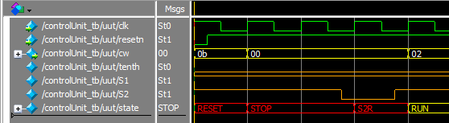

Figure 10: A small segment of the testbench simulation showing how Listing 1 encodes state names.

Run the entire simulation and compare the simulation output to Figure 6 through Figure 9. Use the results of the simulation to either correct Figure 6 through Figure 9 or to correct your controlUnit.v code.

# 4 Turn in:

You may work in teams of at most two. Make a record of your response to the items below and turn them in a single copy as your team’s solution on Canvas using the instructions posted there. Include the names of both team members at the top of your solutions. Use complete English sentences to introduce what each of the following listed items (below) is and how it was derived. In addition to this submission, you will be expected to demonstrate your circuit at the beginning of your lab section next week.

**Control Unit Design**

* Completed Table 1
* Completed Figure 6 through Figure 9.
* Verilog code for the body of the control unit module (courier 8-point font single spaced), leave out header comments.

**Control Unit Simulation:**

* Produce a timing diagram with the following characteristics. Zoom to fill the available horizontal space with the waveform. Format the waveforms as follows.
  + clk default green trace
  + resetn default green trace
  + cw hex yellow trace
  + tenth default orange trace
  + S2 default orange trace
  + S1 default orange trace
  + state special red stop/stop2reset/reset/stop2run

yellow run/inc/run2lapRun/run2stop

orange lapRun/lapInc/lapRun2run/lapRun2lapStop

green lapStop/lapStop2run/lapStop2LapRun

* Demonstrate your simulation and your do file works in ModelSim.